**Test Document**

Child’s Play

Comp 4981

**Abstract**

Test document of all the tests that have been run on the game.

Table of Contents

networking 3

connecting to server 3

Steps 3

Expected Result 3

Actual Result 3

syncing up Multiple clients 3

Steps 3

Expected Result 3

Actual Result 4

disconnecting From Server 4

Steps 4

Expected Result 4

Actual Result 4

Selecting team and Role from lobby 4

Steps 4

Expected Result 4

Actual Result 4

graphics 5

draw New Units 5

Steps 5

Expected Result 5

Actual Result 5

Removes Dead Units 5

Steps 5

Expected Result 5

Actual Result 5

control 6

movement 6

Steps 6

Expected Result 6

Actual Result 6

AI 7

Creep attacking 7

STEPS 7

Expected Result 7

ACTUAL RESULT 7

Creep pathing 7

STEPS 7

Expected Result 7

ACTUAL RESULT 7

Creeps dying 7

STEPS 7

Expected Result 7

ACTUAL RESULT 7

Tower attacking 8

STEPS 8

Expected Result 8

ACTUAL RESULT 8

Tower dying 8

STEPS 8

Expected Result 8

ACTUAL RESULT 8

Castle dying 8

STEPS 8

Expected Result 9

ACTUAL RESULT 9

Game logic 10

Unit killing 10

STEPS 10

Expected Result 10

ACTUAL RESULT 10

Selling towers 10

STEPS 10

Expected Result 10

ACTUAL RESULT 10

Buying tower 10

STEPS 10

Expected Result 10

ACTUAL RESULT 10

Game lost 11

STEPS 11

Expected Result 11

ACTUAL RESULT 11

Game won 11

STEPS 11

Expected Result 11

ACTUAL RESULT 11

game logic test 11

STEPS 11

Expected Result 11

ACTUAL RESULT 12

Testing Document

# networking

## connecting to server

### Steps

Begin the server

Begin the client

Choose Join from the main menu

Enter the IP and port of the server

Click Connect

### Expected Result

Client connects to the server, and the game lobby is displayed.

### Actual Result

Client connects to server, game lobby is presented with a list of currently online players. Server logs new client joining to the console.

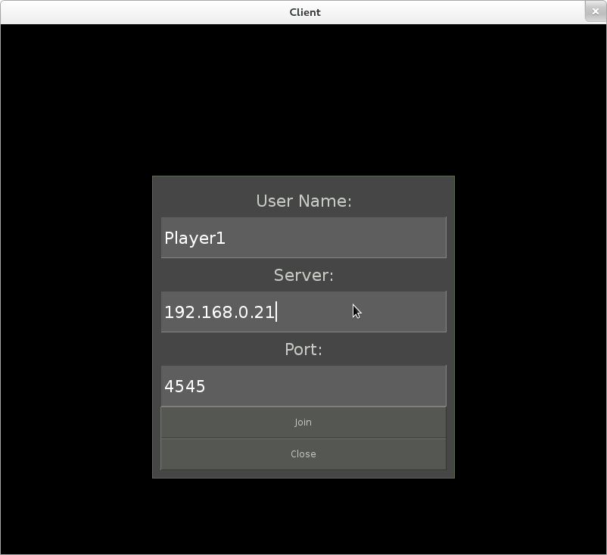

## syncing up Multiple clients

### Steps

Begin the server.

Connect two or more clients

Monitor both clients

### Expected Result

Client windows have no visible lag or discrepancy between each other.

### Actual Result

Both clients connect, both clients present in player list. Updates to one client are presented on the other client with no perceptible latency.

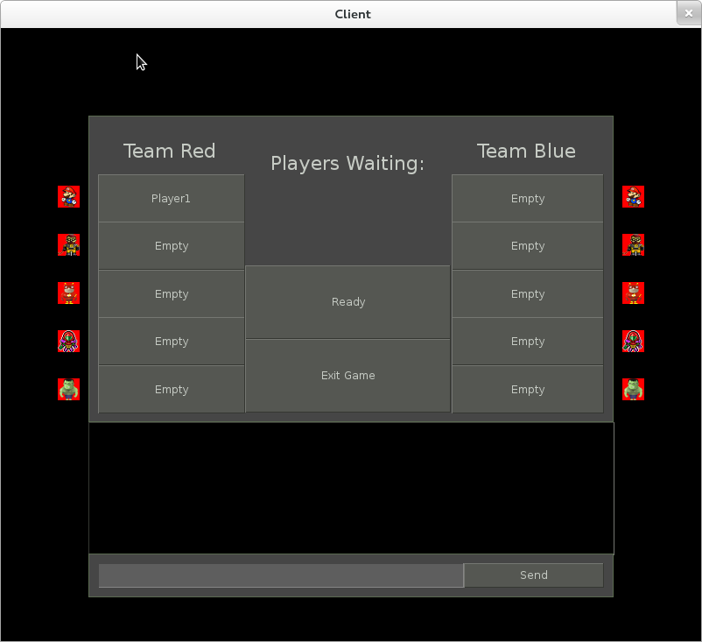

## disconnecting From Server

### Steps

Connect multiple clients.

Close all the clients but one.

### Expected Result

Game continues playing normally

### Actual Result

Remaining client displays other members leaving the lobby. Lobby does not close, any position the remaining player is in remains in its current state. Server logs clients disconnecting to the console.

## Selecting team and Role from lobby

### Steps

Connect to the server, and enter the lobby window.

Pick one side of slots, and then click one.

### Expected Result

Player will join that team, as signified by their name in the slot clicked.

In game, the player will only have access to controls that correspond to that role.

### Actual Result

Client connects to server. User is initially displayed in the Players Waiting list. Upon selecting a team, said player is removed from the Players Waiting list, and is moved to the selected position. User is on appropriate team upon game start.



# graphics

## draw New Units

### Steps

Begin the client.

Connect to server

Choose Builder role

Click on buttons in HUD

If the unit is a tower, the map must be clicked after clicking button.

### Expected Result

Fully functional units are built and placed in the correct location.

### Actual Result

The selected unit is created with its expected behaviours.

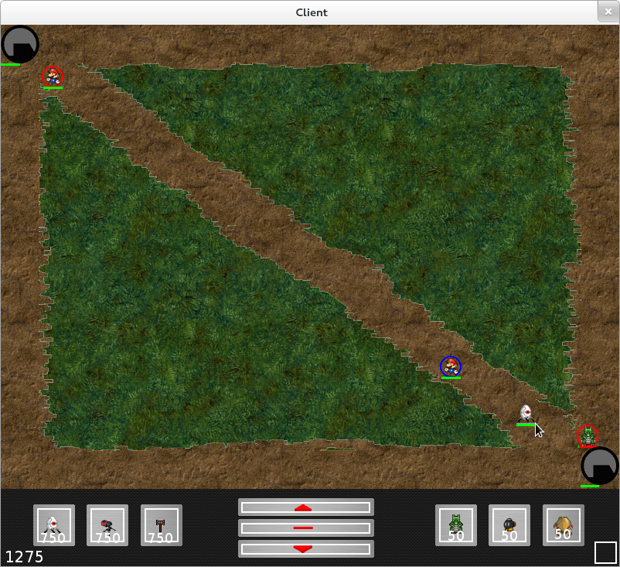

## Removes Dead Units

### Steps

During gameplay, slay a turret or a creep by reducing its health to 0.

### Expected Result

Unit should be removed from map, leaving no trace behind.

### Actual Result

Dead unit is removed from the map

# control

## movement

### Steps

Enter the game using the Player role.

Use the WASD keys to move around.

### Expected Result

W moves the player upward.

A moves the player left.

S moves the player downward

D moves the player right.

### Actual Result

The player gains full control to the character chosen.

# AI

## Creep attacking

### STEPS

Test if the attacks dealt and handled properly

### Expected Result

If the attack hits the target opponent unit, the HP of that until should be reduced depending on the amount of attack dealt.

### ACTUAL RESULT

The HP of the target is reduced when it is hit by an AI creep.

## Creep pathing

### STEPS

Test if the creep follows the right path while moving

### Expected Result

The creep follows its own path toward the opponent castle

### ACTUAL RESULT

Each creep follows its own path toward the enemy's base.

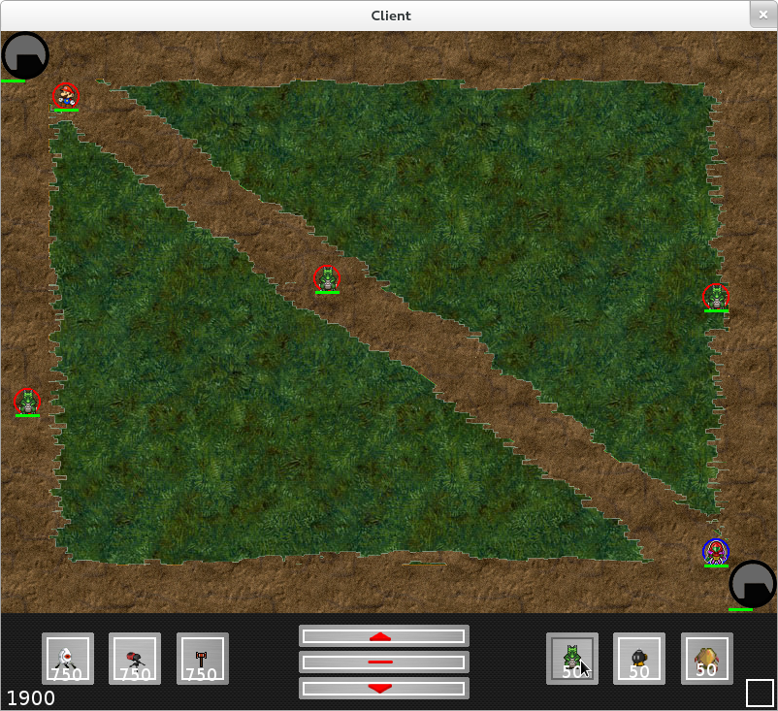

## Creeps dying

### STEPS

Test the behaviours of the creep when the HP reaches zero

### Expected Result

When the HP of the creep reaches 0, it disappears from the field

### ACTUAL RESULT

Dead creep gets removed from the field.

## Tower attacking

### STEPS

AI tower attacks enemy units automatically

### Expected Result

AI tower attacks when an opponent unit comes within the detectable range

### ACTUAL RESULT

AI tower attacks enemy whenever one comes within the range.

## Tower dying

### STEPS

Test the behaviour of the AI tower when it gets destroyed.

### Expected Result

AI tower disappears from the field when its HP reaches zero.

### ACTUAL RESULT

Destroyed tower is removed from the field.

## Castle dying

### STEPS

Test the behaviour of the AI castle when it gets destroyed.

### Expected Result

AI castle disappears from the field when its HP reaches zero and the game ends.

### ACTUAL RESULT

Game ends when the castle is destroyed.

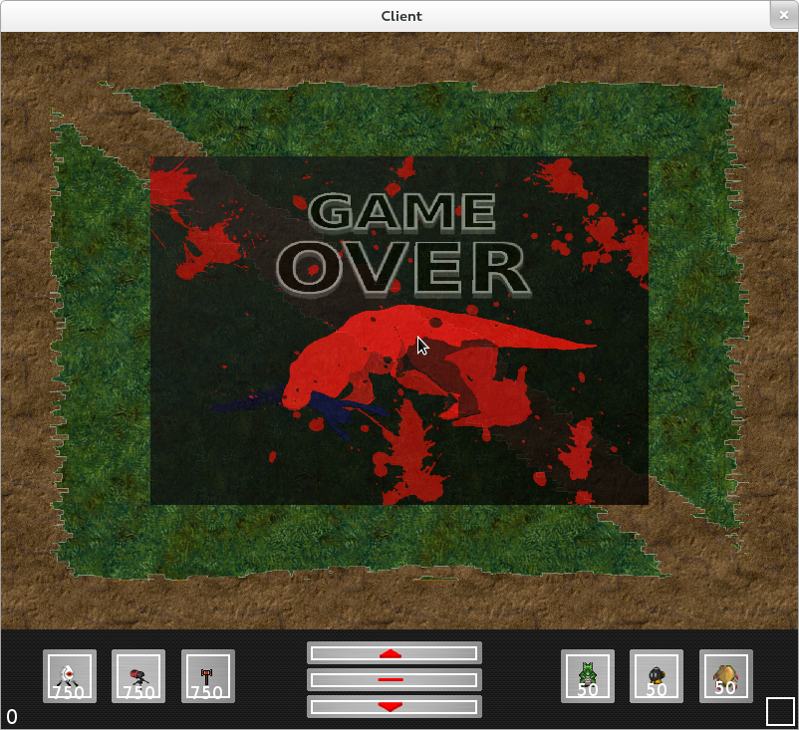

# Game logic

## Unit killing

### STEPS

Test the behaviour of the unit after it gets killed.

### Expected Result

The HP reaches 0. The unit should disappear and then waits for respawn.

### ACTUAL RESULT

Unit disappears from the game and respawns after a few second.

## Selling towers

### STEPS

Test the behaviour after selling a tower.

### Expected Result

The tower should disappear on the field, and the team should receive a correct amount of gold.

### ACTUAL RESULT

The tower is disappears from the field, and the correct amount of currency is added to the team.

## Buying tower

### STEPS

Test the behaviour after purchasing a tower.

### Expected Result

The tower should appear on the field at the right position, and an amount of gold should be deducted from the team.

### ACTUAL RESULT

New and functional tower is on the field, and the right amount of gold is taken from the team.



## Game lost

### STEPS

Test the behaviour of the game on the losing team when the game ends.

### Expected Result

A losing screen with a button for the user to go back to the main menu will be displayed

### ACTUAL RESULT

The losing screen is displayed. The losing music is play.



## Game won

### STEPS

Test the behaviour of the game on the winning team when the game ends

### Expected Result

A winning screen with a button for the user to go back to the main menu will be displayed

### ACTUAL RESULT

The winning screen is displayed. The winning music is play.

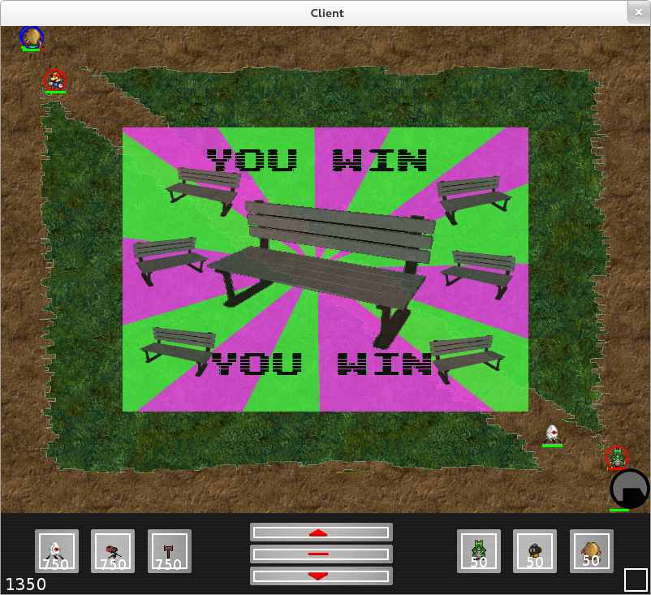

## game logic test

### STEPS

Different messages are sent back and forth between the server and the clients even in the lobby.

### Expected Result

Message is sent to the server whenever a client selects a position in a team to ensure that the selected position is available and a valid choice.

Messages are sent between the server and the clients before the game starts to ensure that each client in each team is in the “Ready” state.

### ACTUAL RESULT

All the necessary messages are sent and received on both the server and the clients.